**[Access Deep Web](https://null-byte.wonderhowto.com/how-to/access-deep-web-0166145/)**

* By [**C@pt&in An0n k.c**](https://creator.wonderhowto.com/anonpratik/)
* 11/12/2015 12:44 am

This is my first tutorial and it is about accessing deep web for total beginner,sorry in advance if I make any mistake plz forgive me.

Introduction:Internet has commonly three parts as per my knowledge 1st:surface web,2nd :Darknet and 3rd :Deep web

Surface web:We use surface web most of the time and they are websites or resources which can be accessed by search engine such as google,bing, duckduckgo or anything.They are the sites which can be accessed by our simple web browser like Firefox or chrome.It is in upper part in internet.

Darknet :Darknet or clearnet are basically middle of internet which contains both surface web and deep web resources.It is smaller than deep web and it is used for mostly file sharing and other like privacy,cybercrime,leaks.It is not too deeper.you will need tor browser to access it.

Deep web:This is the last stage of internet as per my knowledge but people say there are upto 8 stage of internet like mariana web or something.but I will particularly tell about deep web. It is in below of darknet and surface web.The website of deep web is also not indexed by standard search engine.so you basically need tor browser. This size of deep web is approx 550 times larger than surface and it consist of about 7.5 petabytes so you can think yourself how big it is.Things in deep web is more worst than deep web like Hitmens for killing,Malicious hacker for hire,child pornography,They can Hack you're own camera,disturbing videos and image like ISIS red rooms,drugs,marijuana and many worst things.you should always think before going to it.

**Browser(Tor Broser)**

First of all you will need a browser known as tor and to get it just go to:[https://www.torproject.org/download/download.html.en](https://www.torproject.org/download/download.html.en" \t "_blank) and download the latest version for you're computer.

Then open you're tor browser then it will connect to tor network.then you will see a windows like this.

[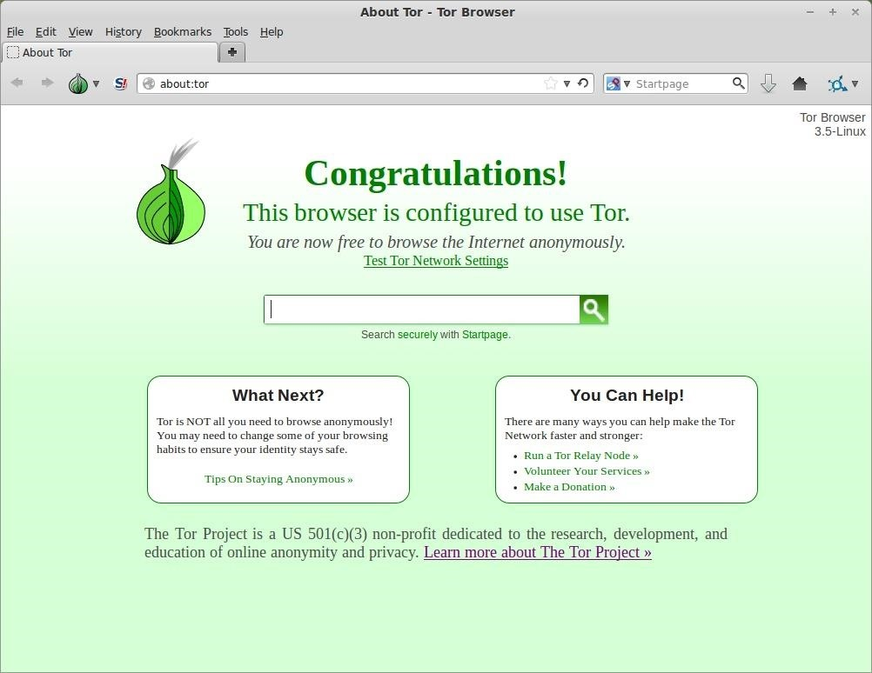](https://img.wonderhowto.com/img/original/90/86/63582796650344/0/635827966503449086.jpg)

*Image via* [*wikimedia.org*](http://wikimedia.org)

It will say that you're connected to tor.then you're ready to go.

**Step 1Privacy and Anonymity**

Important step:There will be S logo in left of browser click on it and click"forbid scripts globally" and most important step is to be safe before going to deep web.Use vpn or proxy before accessing deep web because there are many malicious people in deep web which will hack you're privacy and can do anything to you.I personally suggest you to use I2P and turn on you're firewall and antivirus if you have.You can do anything like covering camera with tape or anything and don't download anything from deep web which will harm you.you know what I'm talking about or you and you're privacy may be on deep web like this:

[](https://img.wonderhowto.com/img/original/27/89/63582797395704/0/635827973957042789.jpg)

*Image via* [*arstechnica.net*](http://arstechnica.net)

**Step 2Going Deeper with Tor**

You can go to hidden wiki:

<http://kpvz7ki2v5agwt35.onion.to/wiki/index.php/Main_Page>

Search engine known as Torch where you can search things:[http://xmh57jrzrnw6insl.onion.to/](http://xmh57jrzrnw6insl.onion.to/" \t "_blank) and best private search engine known as Duckduckgo:<https://3g2upl4pq6kufc4m.onion.to/>

File sharing links:<https://oukryuqqc7ffenin.onion.to/>  
<http://shxdhomhggy3bjrn.onion.to/skyfortress.php>  
<http://ocrlwkklxt3ud64u.onion.to/>  
<http://i7hknwg4up2jhdkx.onion.to/>  
<http://3fnhfsfc2bpzdste.onion.to/>

Wikileaks:http://gjlng65kwikileax.onion/   
http://zbnnr7qzaxlk5tms.onion/

facebook:https://facebookcorewwwi.onion/

These are the good ones but you can get bad and worst things in deep web such as drugs,child pornography,disturbing images and videos,weapons,hitmens for killing people,blackhat hackers for hire.

If you want these things whole links are in here:

<http://securityzap.com/massive-deep-web-links-2015-updated-june-2015/>

Warning:But plz be careful while going to deep web because it may make you're life worse because I go to it once a day for seeing new things like stage of deep web which people talk but everyday I see more worse things.If anything happens to you I am not responsible because I did this post only because I saw many people writing "How to access deep web" and guys this is end of this written tutorial. please forgive me if I made any mistake I will certainly learn from it and make better tutorial.